D.I.E.: Description,
Interpretation, Evaluation
Look at the picture and make the next 3 exercises:
D: Description. The task is to describe only what you see.
I: Interpretation. Now you can say what you think about what you
see.
E: Evaluation. Now you can express your feelings about what you think is
going on.
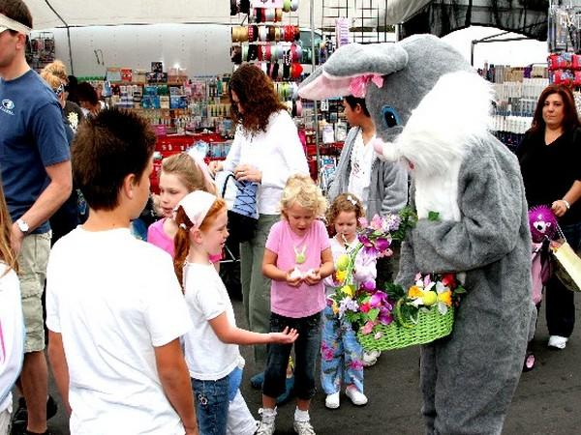
- An Easter Bunny is holding a basket of eggs.
___________________________________________________________________________________
___________________________________________________________________________________
- It could be that an Easter Bunny is giving the eggs to the children for free.
___________________________________________________________________________________
___________________________________________________________________________________
- I think that children are very happy and I’m glad for them.
___________________________________________________________________________________
___________________________________________________________________________________

